Internal Assessment Resource
Digital Technologies: Level 1

This resource supports assessment against Achievement Standard 92005
Standard title: Develop a digital technologies outcome
Credits: 5 Credits
Resource title: My Website

Authenticity of evidence | Assessor involvement during the assessment event is limited to providing general feedback which suggests sections of student work that would benefit from further development or skills a student may need to revisit across the work. Student work which has received sustained or detailed feedback is not suitable for submission towards this Standard.

Student/Ākonga instructions

Introduction
This document supports the teaching and learning contained in:
https://www.secondary.techquity.co.nz/level-1/l1-website-project/website-outcome
Follow the website for instructions and complete this document as you go.
You are going to design and make a website using Figma, HTML and CSS, Github and Visual Studio Code over 6 weeks.
You will make this website entirely in HTML and CSS. CSS Frameworks are not to be used. You may also use ‘vanilla’ JavaScript to make your websites interactive. Libraries or other packages are not to be used and all scripts must be ‘client side’.
Please ensure you have a sound grasp of HTML, CSS and JS before attempting this assessment. It is highly recommended that you have completed all the work on this page before attempting this assessment.You will be expected to be able to follow basic software engineering and web development conventions during this project.
Conventions include but are not limited to:
- Using an organised file structure for your project files
- Using well named files and folders in your project
- Using code comments where appropriate
- Following common language conventions for HTML (info here)
- Following common language conventions for CSS (info here)
- Following common language conventions for JS (info here)
- Using version control including descriptive commit messages
You are encouraged to incrementally develop your website through weekly iterations of “plan-develop-test”, keeping a record of your progress as you go. Git Version control and your Kanban Board should be used as evidence of this.
If you are unable to use git, multiple files in your source code folder must be made with version number included.
You will submit the working website (hosted on github or a zip of your entire source code folder) as well as this document for assessment against the criteria listed above.
It is recommended that your project be structured around an interactive quiz or study guide for a subject you are passionate about. Make sure you correctly identify the appropriate target audience for the content. Examples include:
- A chemical elements quiz.
- A Te Reo Māori translation test
- A music notes flashcard game
Complete the following questions.

Before Development

What is the purpose of this website
To provide a study website for biology. The website will test the knowledge of the user by asking questions that require the definitions of biology terms in a fun and interactive quiz.
Biology is one of the hardest sciences because it requires a strong memory to know definitions. The definitions vary from short sentences to paragraphs, the quiz will ask the user to click on the right answer. The Theory behind the quiz is spaced repetition, allowing the users to practise their definitions many times.

Who might use this Website?
- Year 11 students doing sciences.
- Year 12 - 13 doing biology who need to revise simple definitions.
- Students in high school and above that wish to broaden their knowledge of biology

What are the requirements and specifications for this website?
Requirements | Specifications
- It is required to have an aesthetic landing page with a link to the quiz.  - It is required to have fifteen questions with four possible answers.  - It will allow users to answer biology based questions through both multichoice questions and text questions.  - It will have an answer sheet for a backup if the user can't find the correct answer. | - Written in pure HTML CSS the quiz will be implemented with Javascript.  - There needs to be a results page that displays the quiz results once it is finished.  - All buttons will have an underline to show it is a link.  - Deployed on the public internet and github.

High Fidelity Mockup- Paste your Mock up here.
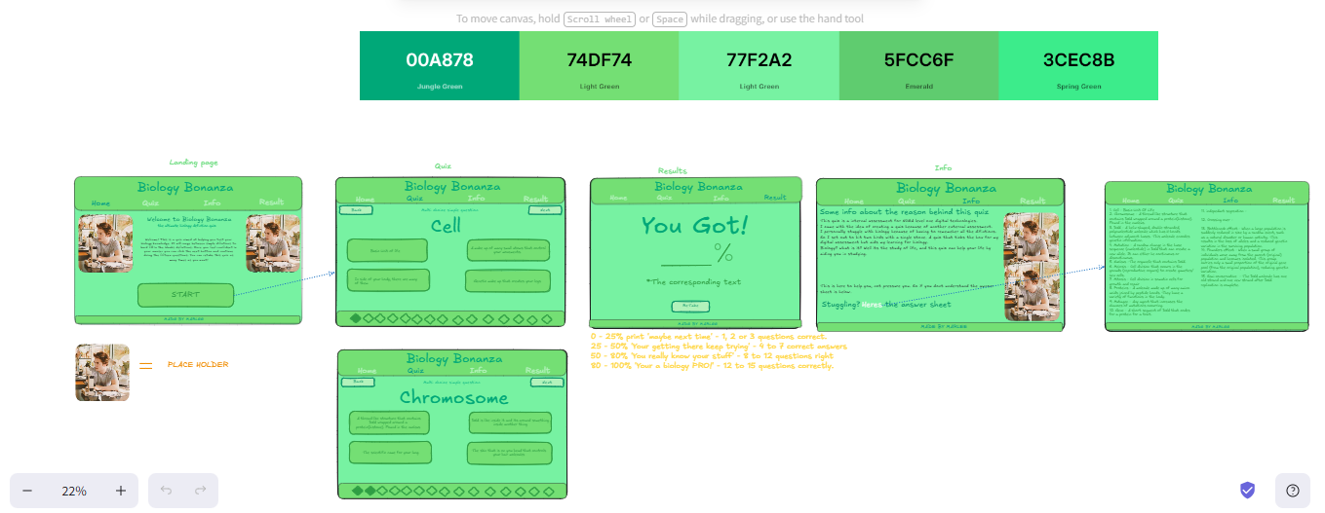

Initial Planning Board

Insert a screenshot of your kanban/github project planning board with at least 10 “tasks” before starting development.
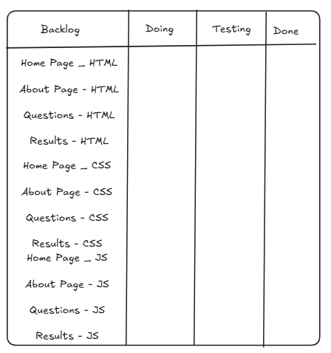

Develop Your Website

At the end of each sprint you must test your website with at least three people. The more the better!
Take a few screenshots of the site at this stage as your showcase and summarise the feedback that you got from people so that you can work out what to do next and how to make your website better.

Showcase Version 1
Date:
Insert Picture of site at this stage of development. Get feedback on the site at this stage to help you to make improvements
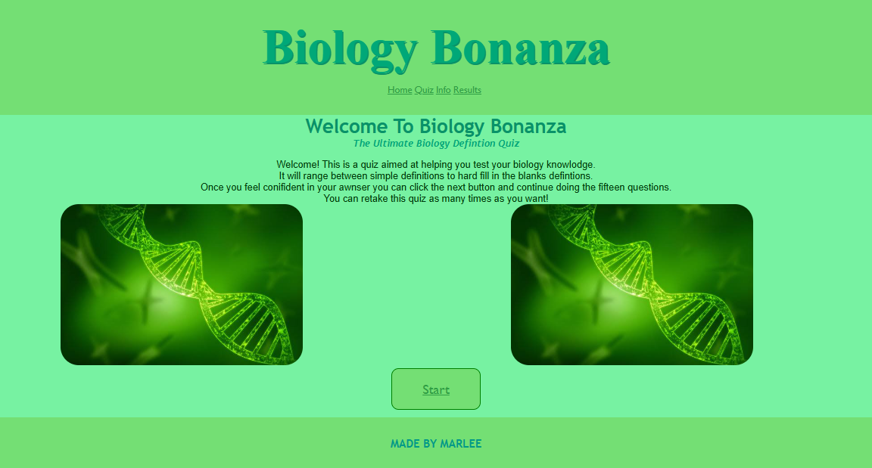
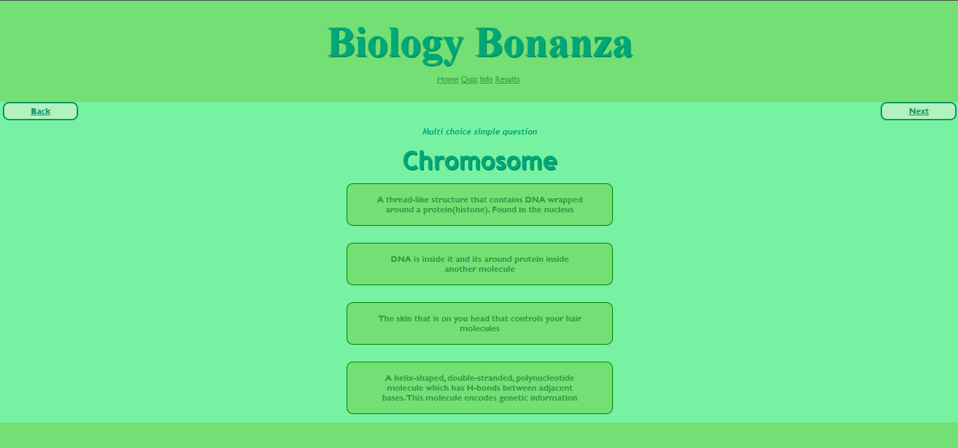

Summary of Feedback and next steps
Eirana said that I should make the button on the home page more prominent so it can be easily identified as the starting button. I am using this feedback to make all the letters inside the button to be capitals so it stands out as a louder option. I also will write in the introduction text in between the images ‘click START to begin’ guiding the eyes of the user to the button.
Natalie said that I should add a better hover effect on the question boxes when the mouse is on top of the box. My current one is a darker shade of green, and no changes to the text, so I am using this feedback to use CSS to make the colour of the unhovered boxes background and text switch so the same colours are consistently used on the question boxes.
Overall everyone who reviewed my website complimented the consistency of colours, and the shades that were used for each page.

Updated Planning Board- what my board looks like now.
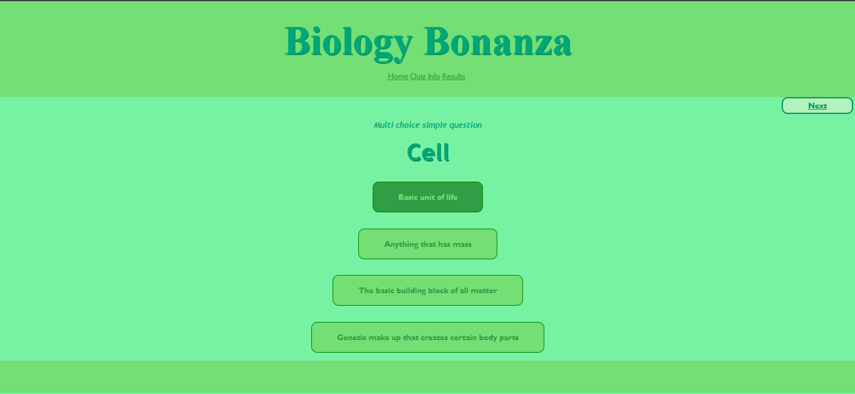
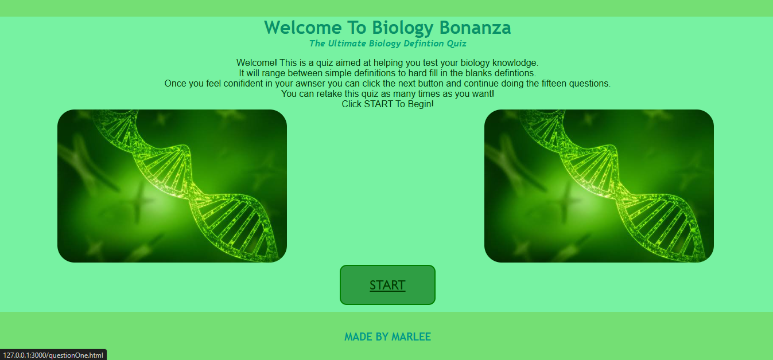
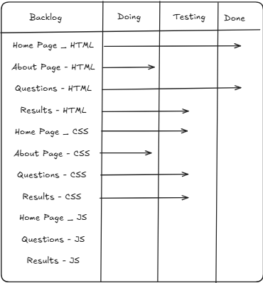

Showcase Version 2
Date:
Insert Picture of site at this stage of development. Get feedback on the site at this stage to help you to make improvements
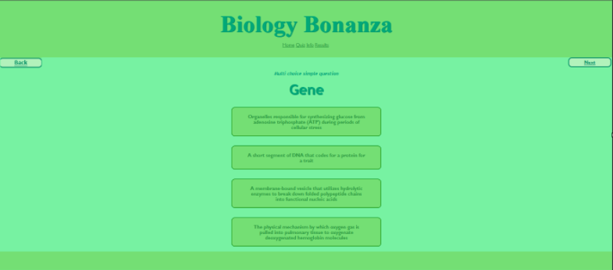
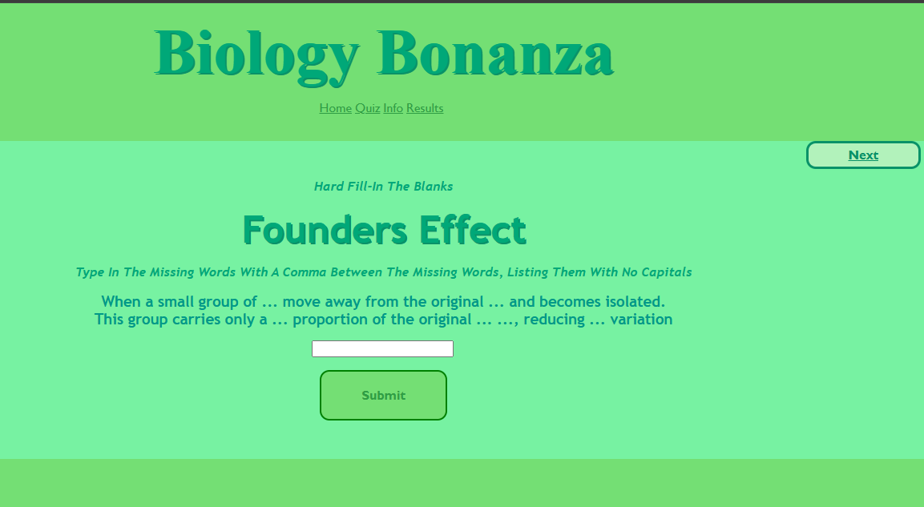

Summary of Feedback and next steps
Olive said that I should remove the back button on each question because the buttons became unclickable therefore there was no need to go back to the pages. I am using this feedback to remove the back button and just have a next button in the top right corner.
Natalie commented that I should change the layout of the information page to have a smaller image instead because there wasn’t enough writing to support a large image. I am using this feedback to shorten the height of my image on HTML, and moving the writing to be on the left of the image with CSS.

Updated Planning Board- what my board looks like now.
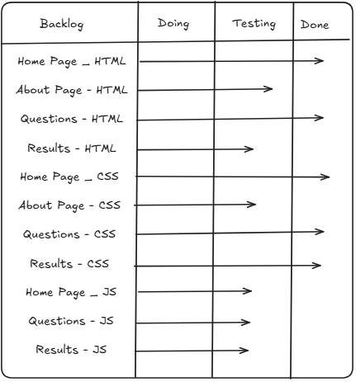

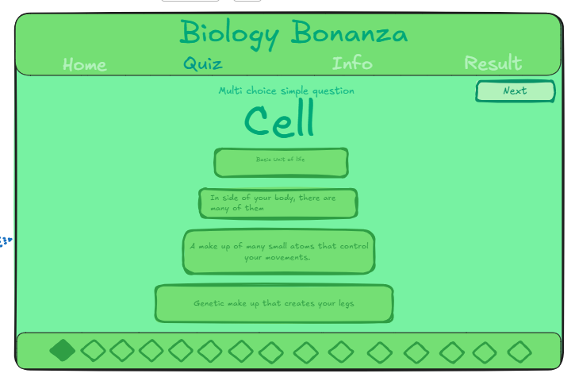

Showcase Final Version
Date:
Final Version. Add screenshots of the final website.

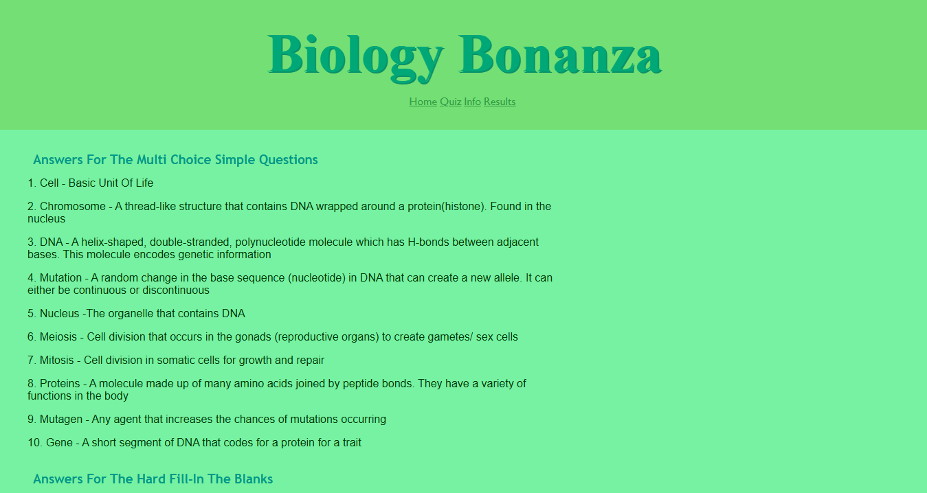
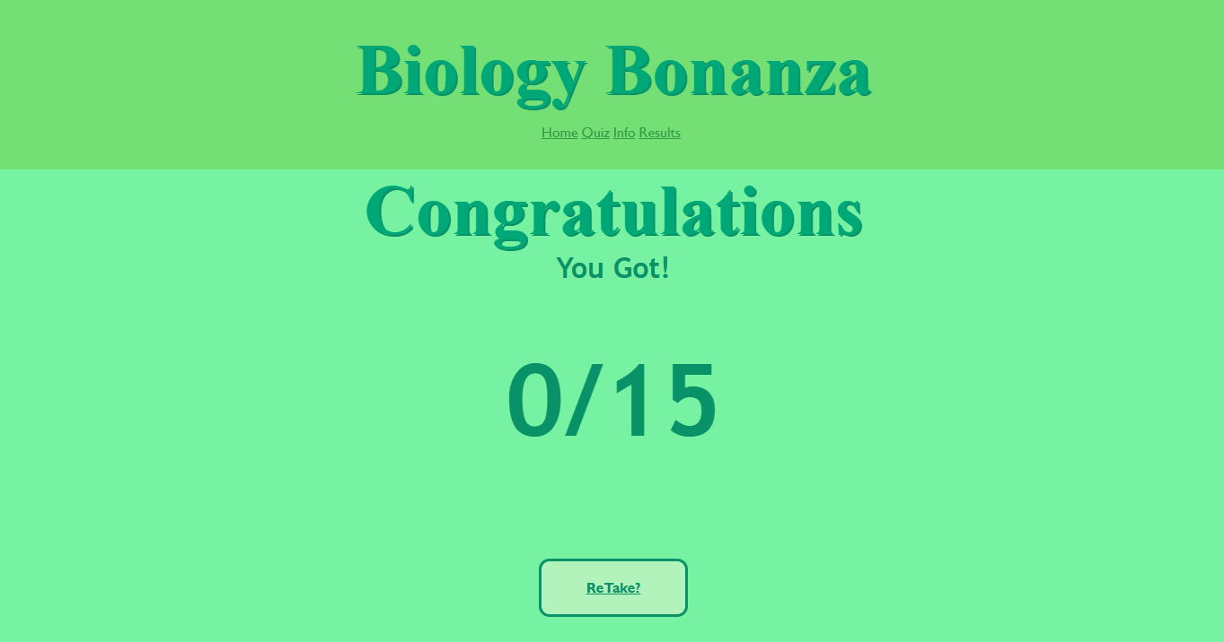
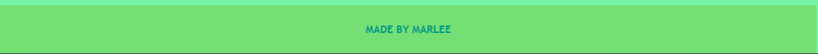
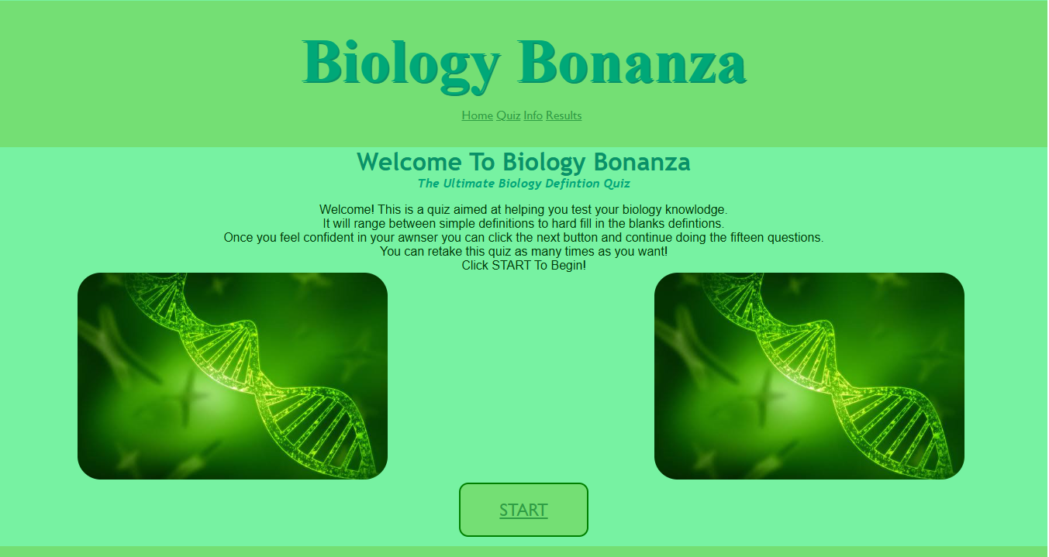

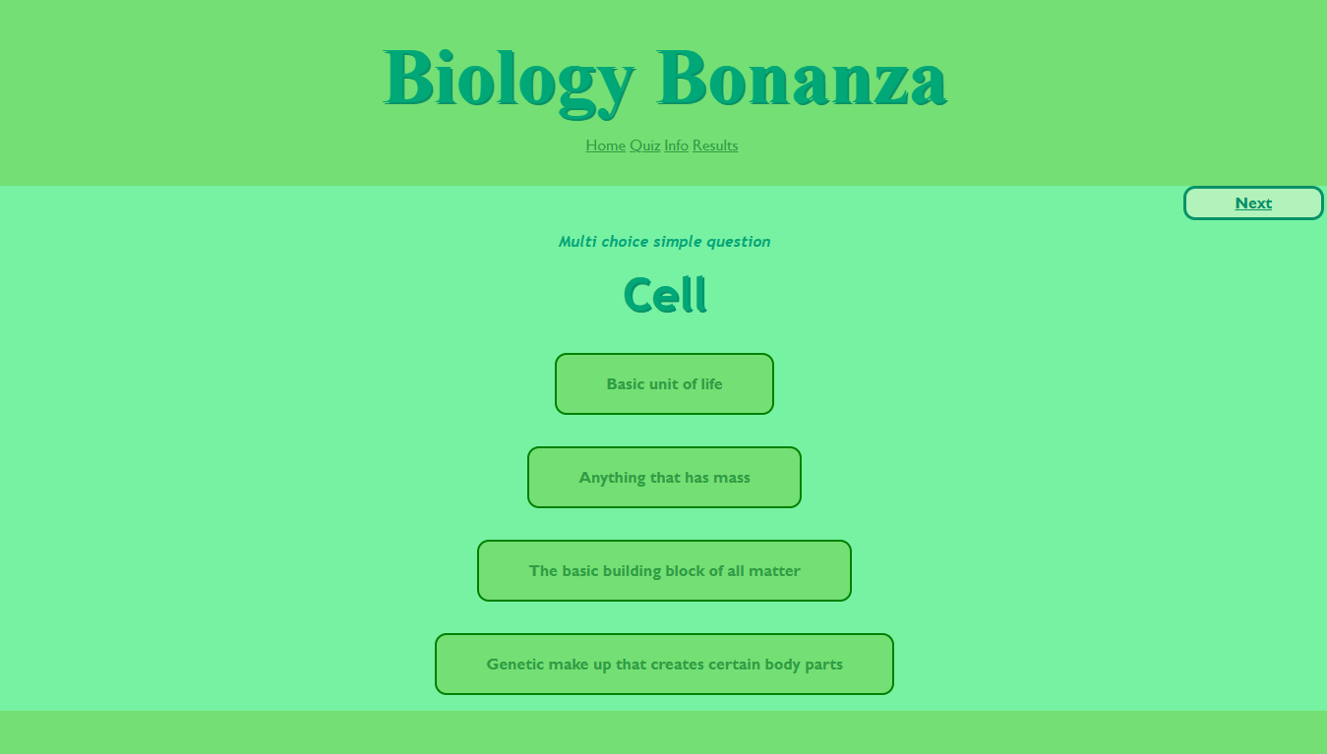
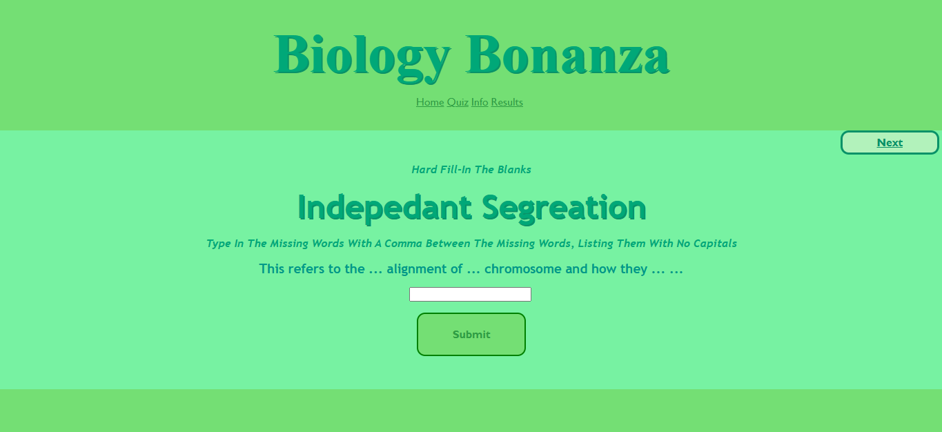

Final Reflection on Website
Long answer. For excellence include evidence of how you tested and trialled the outcome with others and how, with examples, this helped you to make the website better. What cool techniques or tools did you use to make the website stand out and meet the requirements that you intended at the start.
Looking back on my website, I have concluded that I have successfully created the website I set out to make. My objective was to create a website that would help biology students study through multiple choice questions along with text input questions. In my mockup, I kept the index page and the results page the same, I did make slight changes when developing my questions and information pages.
When making my home page, I began with my navigation bar as I felt it was needed to remain consistent on each page and to link the website as one cohesive piece. For my two main images on the index page, I initially struggled to get them spaced equally above the ‘start’ button. At first I couldn’t figure out how to get them on the same line, which occurred because I had placed the images above and below the button in the HTML. After realising I needed to reorder my HTML elements, I utilised my CSS to align the images correctly using margins and borders to match my high fidelity mockup.
For my title in my navigation bar, I didn’t originally use a darker green shadow effect; I chose to make this change after reviewing a classmate's website. I loved how it looked, and therefore, in response, I implemented a similar shadow effect. Once I managed to figure out the right amount of pixels to use on the shadow in CSS, I was very pleased with how the index page looked.

When choosing the layout for my multiple choice questions, I initially wanted a two by two grid configuration. However, when I began coding, I ultimately decided to arrange them into a vertical, single column structure. Organising my questions like this would also provide a better experience for the biology students using the quiz because it prevents the screen from being cluttered with too much information as soon as the page opens. Instead, they can scroll down and individually read all the options.

The colouring I used for the buttons was a very difficult decision because I wanted to maintain consistency with the shades of green. I wanted a green colour platette because I felt it complimented the biology theme, whereas suddenly introducing a completely new colour felt out of place. I also wanted to implement a hover state effect. Originally, I used a darker shade of green as the hover on the button by using CSS, but after the first showcase of version one, the feedback was to make the buttons more readable. I decided to invert the background colour with the text colour upon hover. I did this by separately giving CSS to the text and box when the mouse was hovered over them. This approach led to a bug because when the user hovered over the edge of the button where there was no text, the box inverted properly but the text disappeared because it matched the button colour. I knew I had to use CSS but I couldn’t immediately figure out how to fix this. After receiving guidance from my teacher, I resolved the issue by implementing the hover states in the same ruleset.

When deciding on harder questions, I wanted to support biology students who want to challenge their knowledge. I decided to use a text input box that required users to type a list of answers for the fill in the blank format. I structured this with HTML, by making a form containing a submit button. I had to figure out how to use CSS to centre the input box on the page. To centre the box along with the submit button, I wrapped them in a container div, applied margins, and used display flex, which allowed me to align the button perfectly under the text box.
I conducted a blind usability test on these text inputs by asking a classmate to test the questions in case the instructions or the questions were hard to interpret. They were able to correctly identify what they needed to do, and understood how to use the system to submit their answer. I used three dots to show missing words which the user confirmed helped them identify how many words were expected. The finalised idea changed from my original mockup where I had planned to either use multiple choice options from my fill in the blank or have the user write a full definition. Ultimately, I rejected the full definition approach because written answers vary too much from person to person, and I was unsure on how to write such a complicated program. Therefore, I merged my ideas into a text input to fill in the blanks.

I wanted my quiz to work and give the user results, which meant I had to use JavaScript.
Learning how to write and understand JavaScript was a challenge, and I spent a lot of time trying to understand the concepts I would need to create a working quiz. For my questions I wanted the word ‘correct’ or ‘incorrect’ to display after a user clicks. As a class we learned basic JavaScript for coding a quiz question, therefore, I used this for my multiple choice and text input questions. The hardest part was figuring out how to make the program count the correct answers towards a final score. I used some resources that we had previously used, as well as some YouTube tutorials. The most helpful thing was figuring out local storage, which saves the score to the browser on each new page. This means the score wouldn’t reset every time the JavaScript reloads the code. Once I was finished with the code, I tested my JavaScript thoroughly by simulating every possible outcome out of fifteen to ensure it would not bug. Once I was consistently happy with the output, I finalised my JavaScript.
Once the quiz was done, I created a results page which shows the score out of fifteen.
I slightly changed my information page because the feedback I received was to simply shrink the image, but I kept the idea of an answer sheet, which I added through a link on the information page.

Overall, I feel like I have learned a lot about HTML, CSS, and JavaScript. Javascript was especially hard because errors weren’t shown until they were run in the browser, and the code would try to run even if it contained errors. My favourite component was CSS because I was able to easily grasp all the functions and how to write a ruleset. Exploring CSS also allowed me to find cool features I could add to my website such as hover states, shadows, and fonts.
I believe I succeeded in my purpose and created a website that could be used by biology students to study for upcoming tests, or just to learn more about the topic in general.

Github Repository Link
https://github.com/marleescott-ai/marleescott-ai.github.io

Final Product: Link to My Website
https://marleescott-ai.github.io/

For Teacher Use

Develop a digital technologies outcome
Domain: Digital Technology 1.2
Standard: AS92005 v1
Credits: 5 (Internal)
Link: https://ncea.education.govt.nz/technology/digital-technologies/1/2?view=standard

Achieved  Develop a digital technologies outcome | Comments
Identifying the purpose, potential users, requirements, and specifications of the outcome | Complete section “Before Development” correctly
Using appropriate tools and techniques of a digital technologies domain to produce an outcome that addresses the requirements and specifications | Use HTML and CSS in an appropriate IDE to create a website from a design that looks and functions as expected and hand it in on time  Handed in all project code as a github link or as zip file.  May not have used github  Final project may not look like exactly like design
Testing the outcome to ensure basic functionality. | Teacher observation of testing and the website looks and functions mostly as expected  May not have feedback or may not have acted on feedback during development
Merit
Refine a digital technologies outcome
Following relevant conventions of a digital technologies domain | Conventions include:  - Organised file structure  - Well named files and folders  - Code comments where appropriate  - Language conventions for HTML  - Language conventions for CSS  - Effectively using version control including descriptive commit messages  Checked and passing against https://validator.w3.org/
Using information from testing to make improvements to the outcome's fitness for purpose. | Did testing and got feedback. Made some improvements to work towards the suggested improvements.
Excellence
Enhance a digital technologies outcome
using information from trialling the outcome with others to improve its fitness for purpose | Lots of improvement through at least three versions. Including relevant feedback from others and implementing suggested changes where appropriate.
applying tools and techniques effectively in the production of a fit-for-purpose outcome. | The final outcome meets the design and specifications and shows an excellent grasp of HTML/CSS to create an above average website that follows all conventions
Teacher Comments:

